UDC 000.000.000 (leave it as is)
N. M. Surname, scientific degree, occupied position
N. M. Surname, scientific degree, occupied position
E-mail: contact@mail.com
Name of organization 1, City, Country
N. M. Surname, scientific degree, occupied position
Name of organization 2, City, Country
Paper Title
Abstract. Brief information about paper content and research results, which could be useful for people doing the scientific search or review. Use the “Abstract” style. Font size 9 pt. Preferred abstract length is 300–450 symbols including spaces. Do not use rare or special characters. Be free to use Greek letters and upper/lower indexes. Due to technical restrictions, in abstracts we allow the use of simple formulas only, typed as a plain text string without special editors.
Keywords: 5–7 words separated by comma or semicolon

Introduction
Dear authors! This file is a template with customized styles for text and other elements formatting. Using the styles allows to significantly simplify the work and produce beautifully looking and more or less standardized papers. Undoubtedly, it accelerates the editorial process. In this file you will find some useful recommendations on writing papers for the Conference. We do not insist on using headings and subheadings like “Introduction”, “Problem statement”, “Expreimental setup”, “Discussion”, “Results” and so on along the paper, but the paper structeure shoud be clearly understandable. Annotation, keywords, conceptual part of the study in any form, conclusion and references list are must!

Formatting the paper

Common requirements
File format. We accept papers in .doc format of Microsoft Word 2003. It would be good if the filename will consist of desired conference session number and surname of the first author. For example: 01_Ivanov.doc. We sugget to save this file under new filename and edit it in the further.
Paper size. An electronic form of proceedings book does not imply strict limits on paper size, but we recommend not to exceed 3–7 pages of A5 format including figures and references. Page margins: upper – 17 mm, bottom – 23 mm, left – 19 mm and right – 19 mm. Paper size (format) is А5 (14.85×21.0 cm).
Styles. When formatting the paper it is convenient to use pre-set styles. The description of styles defined in this template is presented in Table 1. All styles can be displayed by pressing the «Ctrl + Alt + Shift + S» combination of keys. You can either choose the necessary style from list applying them on the selected text fragment or just use the “copy-paste” method to copy and edit already existing elements from this template. Please, do not create new styles and not change any of existing – it may cause troubles for us in proceedings book assemble process.

Table 1. Paper formatting styles in this template
Style name | Description
UDC | UDC number
Authors | List of authors, their e-mails, scientific degrees and occupied positions
Paper Title | Paper title
Abstract | Abstract
Heading 1 | High-level headings of paper sections
Heading 2 | Low-level headings
Text | Basic text
Text + First string: 0 cm | Paragraph without indented line (for example, before the word “where” after formulas)
Marked | One level marked list
Numbered | One level numbered list
Figure | Figure. Technically, paragraph containing centered image. The line below should be Figure Caption
Figure Caption | Figure Caption. Also, this style adds one empty line below
Table Caption | Table caption. It doesn’t add any empty lines above
Table Content | Table content
Table Head | Table head
Formula | Formula. This style determines tabulation positions to center formulas and place its number on the right side
Sponsors | Paragraph with information about grants and other kinds of funding or sponsorship
References Caption | Caption of references list
References List | Items of references list

Head of the paper
Article head starts with russian Universal Decimal Code (UDC) corresponding to the research area. If the UDC system is unknown to you, just leave this field as is, filled with zeros. Use “UDC” paragraph style.
Then follows the list of authors in priority order. Each entry includes initials and surname of the author, scientific degree (if any), occupied position or academic status. It is recommended to specify at least one e-mail (may be more). The name of organization, where written above authors work or study, may be written once or several times if necessary. Use “Authors” style, emphasizing author names by italic font.
Paper title should be marked by “Paper Title” style and be written with each initial letter capitalized in English or in sentence style in Russian.
Abstract and keywords are necessary.

Headings and subheadings
The use of headings inside the paper is at author’s discretion. The style “Heading 1” is intended for headings and “Heading 2” for subheadings. Do not forget to leave one empty line before headings and subheadings.

Basic text
Main part of paper should be typed by regular Times New Roman font with 10 pt. size, single interval between lines, paragraph indent 0.75 mm. Do not add additional intervals between paragraphs. Stick to justified text alignment. Please, allow automatic hyphenation and try to avoid manual hyphenation.
References to all figures, tables and citation sources must be mentioned or explained in the text!
For example: «sensor parameters are given in Table 2, waveforms registered are presented in Fig. 3; known [4] magnetizqation methods, such as…».
When inserting short text fragments recognized from images, copied from internet resources or electronic books, please delete unnecessary (may be hidden) control symbols (non-breakable spaces, soft hyphenations, tabulation and so on) and external styles. Try to paste plain text only. We must warn young authors that copying reduces the originality of paper. Do it for citation needs only.
It is desirable that the text was read by other people, especially the supervisor and co-authors.

Formulas
Formulas must be entered in built-in Microsoft Word Equation Editor 3.0 (all other editors are unacceptable), numbered on the right, centered, marked by the “Formula” style:
(1)
where all the values must be explained before or right after the formula and the word “where”. If the word “where” continues the sentence started before the formula, then put a comma right after the formula and write the word “where” with a lowercase letter from the next paragraph without indent. If the narrative sentence ends with the formula, then put a point right after it and start new paragraph marked with normal “Text” style. We advise you to include comma or point right into the formula (in formula editor), so it will be placed on the baseline level. In the text all references to formulas are given in parentheses, like: “The wave equation (1) shows that…”.
Also, please, do not scale formulas! You just need to do one single setup of equation editor. Open the Equation Editor 3.0. Go to the “Size” → “Define” menu. Change the font sizes as follows:
- Full – 12 pt;
- Subscript / Superscript – 10 pt.;
- Sub-Subscript / Superscript – 8 pt.;
- Symbol – 18 pt.;
- Sub-symbol – 11 pt.

Lagre or high formulas make text lines irregular. It is much better to bring them on a separate line using the “Formula” style.
As for specific symbols (single or in small groups), we recommend to insert them through меню «Insert» → «Symbol» menu, selecting the “Symbol” font.

Graphical elements
Figures and graphs should be presented in reasonably high quality (about 150–300 dpi) with good contrast and be inserted in the paper on their desirable positions. It would be very good if you will additionally send us originals in common graphical formats (*.bmp, *.jpg, *.tif, *.png). Try to avoid too small images or images that are hard to read without magnification. If your image is too big and doesn’t fit in a page without loosing the details, then consider division the image on several figures but remember that each new page should have its own figure number.
There are two kind of figures. One is formatted to occupy the full column width (for images wider than a half of column width, from 5.5 to 11 cm). In this case the “Figure” style should be applied to the paragraph containing the image, and the “Figure Caption” style – to the next paragraph. If the figure consists of several graphical elements or labeled “(a), (b), (c), …” parts, it’s advised to place them all in one rectangle container called “Drawing Canvas”. You can find it under the Insert tab in Shapes tool menu → New Drawing Canvas item. An example is shown in Figure 1. Keep one line distance (visually) between figures and text (or other paper elements).

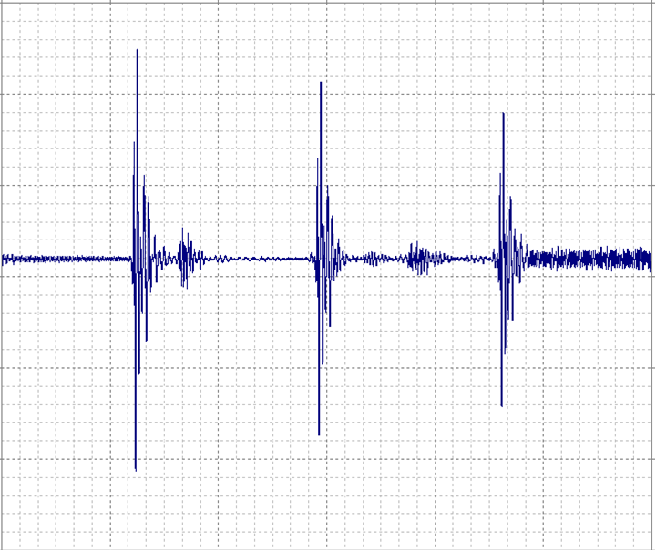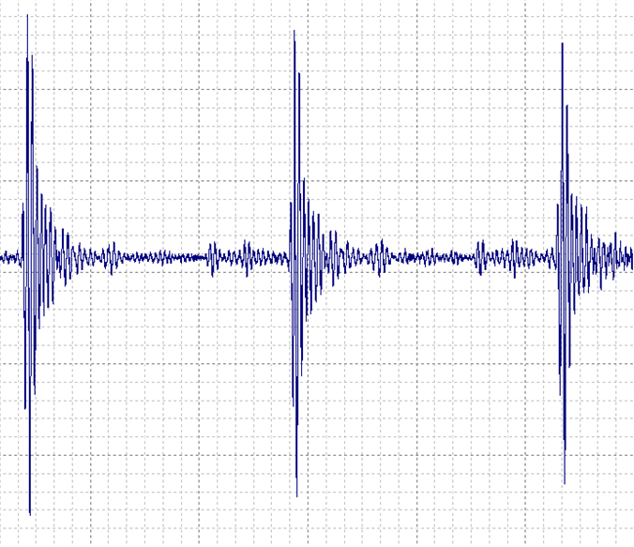
Defect
F mode
T mode
а
б
Fig. 1. Waveforms registered: for the tube with defect (a);
for the tube of small diameter – the signal with flexural mode F (b)
Another case is a figure of width smaller than 5.5 cm, so you can make a word wrapping around canvas and have to place the figure caption inside the canvas as a text box object. For example, see Figure 2.
Do not forget to keep margins around the Canvas.
Fig. 2. Small image in Canvas (rectangle field-container that can be found in “Figures” menu)
Do not forget to mention every figure in the text, like: “The experimental dependencies of value Y on parameter X are presented in Fig. 3”. Do not forget to specify all necessary information on axes (labels, units, numbered or marked scales).

Lists
There are some simple rules about lists:
- Every list has its heading part (a text that ends with colon).
- Items of list starts with line indent and special marker or item number (letter).
- For each numbered list you need to set a start number to avoid previous list numbering.
- List items should look like paragraphs of basic text.
- Each list item ends either with a point (in this case all items start with uppercase letter) or semicolon (in this case all items stert with lowercase letter) symbols. The last list item ends with a point.
- There should be one empty string after the list and before the subsequent text.

Numerical data
The units should be in SI system. If your values are not included in SI, it is possible to use designations adopted in other standards. The designation of the unit is separated from the numeric value by a space (i.e., “5 %”, “0.12 nm”). It is desirable to use the character “non-breaking space”, so the number and unit could not appear on the different lines of text. Round up fractional numbers in accordance with the calculations (measurements) accuracy, but try not to give more than 2–3 significant digits after the decimal point.

Tables
Do not use color filling or bold font in table heads. You can do some color emphasis if it has a meaning or unavoidable.
When you transfer the table to another page you should duplicate a table number and head, for example: “Table 2 (continued)”. Then you create a new table with the same head and size. It is advised to use copy/paste method to duplicate all settings of a table from previous page. Bottom border of broken table left on previous page should be invisible. You can see an example in Table 2.
Lateral borders of all tables are invisible.
An example of typical table is shown in Table 3.
All acronyms and symbols used in a table should be descripted in text before a reference to it.

Table 2. Example of table transition to the next page
 | Experimental sensor 1 | Experimental sensor 2
Magnet size, mm | 12×25×5 | 15×15×5
Type of wave | Longitudinal | Longitudinal
Voltage U, mV | 500 | 500
Number of turns | 24 | 24

Table 2 (continue)
 | Experimental sensor 1 | Experimental sensor 2
Copper wire diameter, mm | 0,315 | 0,315
Amount of sensors | 2 | 2

Table 3. Table caption
No. | Diameter,  mm | Tube length, mm | Wall width, mm | Type of defect | Found by sensor 1 | Found by sensor 2
1 | 14 | 4002 | 2.1 | No defect | – | –
2 | 14 | 4002 | 2.1 | Saw cut | No | Yes
3 | 18 | 4003 | 3.2 | No defect | – | –

References
Please, put links to references along the text in square brackets [1] with consequent numeration, so items in the references list would be ordered by their appearance in the text. “Reference” section should contain no less than 3 sources formatted in APA 6-th standard.
To avoid errors of any kind and save your time it is a good idea to use specialized software, Mendeley Desktop or another, to meet standard requirements. English-speaking authors may find useful the “Cite This for Me” site: http://www.citethisforme.com/, or “Citefast”: http://www.citefast.com/ (it is possible to fill the form or it’s part automatically by specifying DOI or ISBN number). Some examples for various types of sources you may find at: http://www.muhlenberg.edu/library/reshelp/apa_example.pdf.
Russian-speaking authors are advised to follow the set of examples at http://izdat.istu.ru/files/journals/1/public/rules-napr.pdf?download=1 (Section 1.2.6 “References” and Appendix 1) when citing Russian sources (but please, write “Kalashnikov ISTU” instead of “IžGTU im. M.T. Kalašnikov” or something similar). If you cite the text written in your national language, then give, for the first, it’s original title in transliteration (BGN), and for the second, English-translated version in square brackets. One of helpful sites for automatic transliteration is at http://translit.net/ru/bgn/. Please, check the results of automatic formatting or transliteration.
Capitalize only the first word in a paper title, except for proper nouns and element symbols. Try to avoid points after URLs or DOIs. Do not include retrieval dates unless the source material may change over time. If no DOI has been assigned to the content, provide the homepage URL.
It is recommended to cite scientific publications in journals, conference proceedings, monographs, dissertations using use direct links to primary sources. References to search engines, aggregate systems or front-pages of internet sites are not allowed.
References to electronic resources should be actual, with the exact URL address of the document (all characters of the address must be presented in human-readable form, but not in machine formats “%28%31%16...”).
Incomplete bibliographical data and the lack of references in the text may be a reason for refusal in publication of paper by the publisher, even if the Scientific Committee approved the paper content.
Examples are given below in the “References” section.

Conclusion
The final part of the article necessarily contains conclusions reflecting the research results on the merits emphasizing the scientific novelty elements and statements that can serve as a basis for further development of the scientific or technical field considered.

Acknowledgments
This optional section is located after conclusions right before the Sponsors or References section. The word “Acknowledgment” is marked by “Heading 1” style.
The work was supported by… (grants, projects, sponsors). Funding or sponsorship information goes here without any headings. The style is “Sponsors”.
References
For references, please, use the APA v6 style. For non-english sources write a reference in original language right below the references list.

Example for journal article with DOI:
1. Paivio, A. (1975). Perceptual comparisons through the mind's eye. Memory & Cognition, 3, 635-647. doi:10.1037/0278-6133.24.2.225

Examples for journal articles without DOI:
2. Becker, L. J., & Seligman, C. (1981). Welcome to the energy crisis. Journal of Social Issues, 37(2), 1-7.
3. Hamfi, A. G. (1981). The funny nature of dogs. E-journal of Applied Psychology, 2(2), 38-48. Retrieved from http://ojs.lib.swin.edu.au/index.php/fdo

Example for conference proceedings:
4. Martynova, Y. A., Martynov, Y. A., Mustafina, D. B., & Asmolovskiy, V. V. (2014). Ant colony algorithm for rational transit network design of urban passenger transport. In 2014 International Conference on Mechanical Engineering, Automation and Control Systems (MEACS): 16-18 Oct. 2014, Tomsk Polytechnic University. doi:10.1109/MEACS.2014.6986883.

Examples for books:
4. Strunk, W., Jr., & White, E. B. (1979). The guide to everything and then some more stuff. New York, NY: Macmillan.
5. Gregory, G., & Parry, T. (2006). Designing brain-compatible learning (3rd ed.). Thousand Oaks, CA: Corwin.

Example for chapter of a book:
6. Bergquist, J. M. (1992). German Americans. In J. D. Buenker & L. A. Ratner (Eds.), Multiculturalism in the United States: A comparative guide to acculturation and ethnicity (pp. 53-76). New York, NY: Greenwood.

Example for encyclopedia articles:
7. Brislin, R. W. (1984). Cross-cultural psychology. In R. J. Corsini (Ed.), Encyclopedia of psychology (Vol. 1, pp. 319-327). New York, NY: Wiley.

Example for technical or research report:
8. Hershey Foods Corporation. (2001, March 15). 2001 Annual Report. Retrieved from http://www.hersheysannualreport.com/2000/index.htm

Example for newspaper articles:
9. Becker, E. (2001, August 27). Prairie farmers reap conservation's rewards. The New York Times. Retrieved from http://www.nytimes.com

Example for blog post:
10. Lincoln, D. S. (2009, January 23). The likeness and sameness of the ones in the middle. [Web log post]. Retrieved from http://www.blogspace.com/lincolnworld/
2009/1/23.php

Example for website with no author or date of publication:
11. Census data revisited. (n.d.). Retrieved March 9, 2009, from Harvard, Psychology of Population website, http://harvard.edu/data/index.php

Example for standards:
12. GOST R 12.4.213-99. (1990). Occupational safety standards system. Hearing protectors. Simplified method for the measurement of insertion loss off ear-muff type protectors for quality inspection purposes.

